

**East Sutherland Camera Club**

**Competition Software**

**User Instructions**

**Instructions**

**Written by Gerald J Holdsworth**

**Application**

**Designed and written by Gerald J Holdsworth**

**Graphics by Andy Kirby and Gerald J Holdsworth**

**Version 0.12**

Introduction 3

Starting a New Season 4

Photographer Of The Year 4

Monthly Competition 4

Categories 4

Additional Settings 4

The Main Screen 6

Entering Voting Slips 8

Deleting Redundant Photographs 9

Invalid Voting Slips 9

Entering Externally Judged Results 10

Importing Photographs 10

Manually Recalculating Results 10

Results 11

Monthly Competitions 11

Photographer Of The Year 11

Populating The Members List 12

Manually 12

From a previous season file 12

From a CSV file 12

Deleting Members 12

Importing CSV Files 13

Keyboard Shortcuts 15

Other Functions 16

Weblink 16

About 16

Disabled Buttons 16

# Introduction

The competition software has been designed to be as simple as possible, while making it as flexible as possible, and also faster to collate the results. Each season is created individually and is saved to a single file. This file contains all the photograph details and how people voted for the entire season.

This guide takes you from creating a season and takes you through recording the competition results, through to the Photographer Of The Year results.

# Starting a New Season

At the beginning of a new season, you will need to create the season file. To do this, click on the “Create New Season” button (left hand most button on the toolbar) to open the following window:

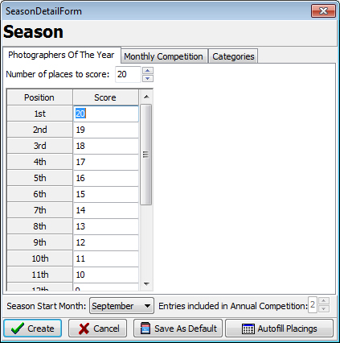There are three parts to the season –Photographer Of The Year, Monthly Competitions, and Categories. There is also the Season title, which is along the top of the window. To change this, just click inside it and edit the title to whatever you desire (usually, it will be the year, e.g. ‘2016/17’).

## Photographer Of The Year

This tab is where you configure the points awarded for each place achieved in the monthly competitions. You can configure the number of places that score points (from a minimum of 3 up to a maximum of 100), and the points each place scores.

## Monthly Competition

On this tab, you can configure how many places are scored, and what points they get per place. This is a minimum of 2 and a maximum of 9.

You can also configure the number of competitions in the season (between 2 and 12), and the details: the month of the competition, the competition title and whether it is judged externally or not.

## Categories

On the final tab you can configure the categories in each competition, between 1 and 6, and their titles.

Once you are happy, click on “Create” to create the file. You will then be asked where you wish to create it.

## Additional Settings

There are a couple of extra settings that make up a season – the start month (i.e. when the club’s season starts every year), and the entries included in the annual competition (i.e. the top most entries, from each monthly competition, which will go forward into the final, annual, competition).

Action Buttons

Along the bottom, there are four action buttons:

* Create : creates the season (this will be ‘Update’ when editing the current season);
* Cancel : cancels all edits and closes the dialogue box;
* Save As Default : saves the settings on the form as the defaults (except for competition names); and
* Autofill Placings : automatically fills the ‘places to score’ on the first two tabs with scores.

# The Main Screen

Once a season has been created, it will be opened automatically. If you have previously created a season, you can re-open it by clicking on the Open Existing Season icon (or by dragging the file from Windows Explorer into the application window). You will be presented with something similar to below (note that you may not have any photographs or members entered yet):

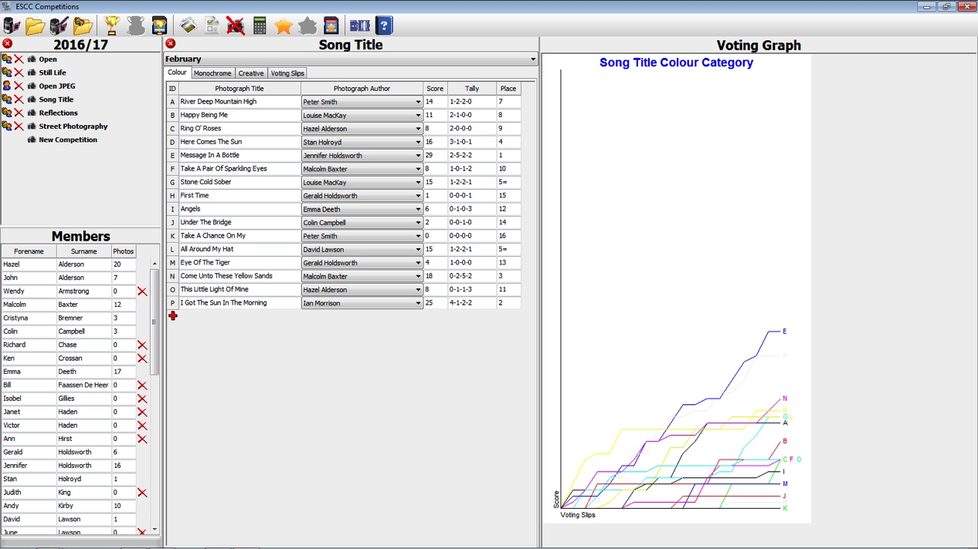

***Season Details***

***Competition Details***

***Member Details***

***Voting Graph***

The main screen is split into three sections. The first, on the left, is split into two. The top are the Season Details. This has the season title at the top (usually the years), and the list of competitions in that season below. Opening a competition is simply achieved by clicking on the competition name. To the very left of the competition name is an icon showing whether the competition is internally or externally judged. Clicking on this icon will toggle between the two (if the competition is not open).

Between this and the competition name is a button, which will delete the competition, or just the photographs in the competition. Beware that this cannot be undone – however, there are a couple of confirmation dialogues to get through first.

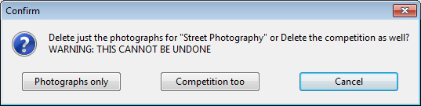 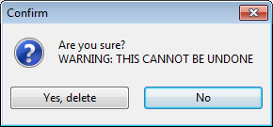

The bottom part of this first pane contains the list of members, which is used to populate the photographer drop down lists in the competition detail pane. Also, next to each member, is a number – this is the total number of photographs the member has entered in the entire season. In addition is a button, which will allow you to delete the member from the list. Not all members can be deleted – only those with no photographs entered can be deleted.

The middle pane contains the competition details. This is further split into tabs, one for each category and one for the voting slips (unless the competition is externally judged). Each category tab lists the photographs ordered by ID number, photograph title, photographer, score received, position tally, and position. Note that if the competition is externally judged, the position tally column will not appear, but there will be a column for Judged Position instead.

If the photograph has no title, or is blank, or if no author attributed to the photograph, then the ID field will be highlighted in yellow to aid the entry of titles and authors.

The right-most pane will display a graphical display of the voting, per category. As you change the category tab, the display will also change. This will not appear if there are no voting slips entered for the competition, or for externally judged competitions.

You will see little ‘Plus’ buttons on the various panes and pages – these are there to add a new entry to that pane/page manually.

# Entering Voting Slips

When you open a competition for the first time, there will be no photographs listed. However, you do not have to enter each and every photograph prior to collating the voting slips, as entering these in will automatically create enough entries.

For example, if you entered a voting slip, where ‘G’ was voted for, the application will create photograph entries ‘A’ through to ‘G’ automatically (as you can not have a ‘G’ without an ‘A’, ‘B’, ‘C’, etc.). It will also add up the scores and work out the places, as you enter each slip. The voting column gives a quick check to see how each photograph has performed.

There are two ways of entering voting slips. The first, which is by clicking on the toolbar icon “New Voting Slip” will open a window similar to the slip given to the judges:

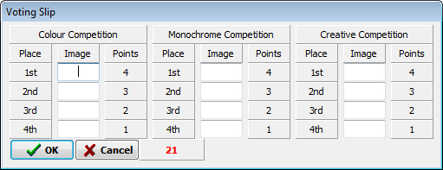

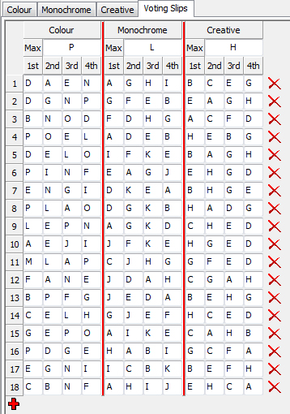It is here where you can just copy exactly what is written on the slip onto the window, and click OK to accept it. To move between each edit field, just press TAB on the keyboard. Once you have entered all the necessary fields, click OK to save it, or Cancel to discard it. You can also press ENTER to save, or ESCAPE to cancel. The number next to the OK and Cancel buttons is a counter to the slip number, to help you keep track of which have been entered.

The second way is by opening the Voting Slips tab and using the ‘Plus’ button to add new ones. You can also have this tab open while entering the voting slips with the above method, if you wish, as a check to see what you have entered. The slips have also been numbered on the tab.

You can also use this tab to change anything, if you have made a mistake. Next to each slip will be a delete button. Clicking on this will render the slip in red, and make it read only. Clicking on the button again will ‘un-delete’ it. This only gets deleted after you have closed the season (e.g. by closing the application).

## Deleting Redundant Photographs

The application can also remove entries that may have been entered by mistake. It does this by working from the bottom up, and removing any entry which has a zero score and no author, until it reaches the first with a score or an author.

## Invalid Voting Slips

There are occasions when the application will reject the voting slip entered. You may notice at the top of the Voting Slip tab, under each category, an edit box labelled ‘Max’ – this is the maximum, or highest, ID that the application will accept. This is not remembered, so when you move off this competition, and come back, it will reset to the default (which is either the highest ID used, or ‘ZZ’ if no slips have been entered). The idea behind this is to try and reduce the number of typing errors when entering slips. So, once you have laid out all the photographs, and ID-ed them, make a note of the highest letter in each category and enter it here, ready.

Now, if you do go over this when entering a voting slip, you will get informed thus:

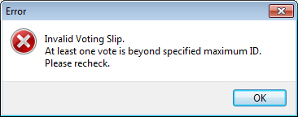

And, once you click OK, your voting slip will let you know what entries have gone over the maximum, by colouring them red:

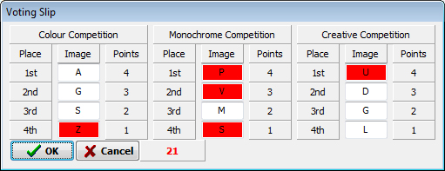

The other issue you might encounter, is the following error:

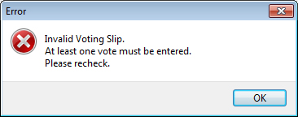

This, essentially, means that you have a blank voting slip.

If you go over the maximum when entering directly onto the voting slip tab, the errant entries will be ignored, and any below it will move up a spot (the same as if you entered a blank entry).

## Entering Externally Judged Results

When a competition is judged externally, there will be no voting slips. Instead, the judge should supply a score (usually out of 20, but there is not limit on this), and possibly a position he/she thinks a photograph should come (usually 1st, 2nd, 3rd, and 4th). The scores can be entered directly into the Score field, and the supplied positions into the Judged Position field. The application will then take these supplied positions into account and work out the positions for the rest of the photographs, and then use the entire results towards the Photographer Of The Year calculations.

## Importing Photographs

Sometimes, you may find that you need to import the photograph details from a CSV file, exported from Excel, say. This can be achieved using the “Import Photographs” button. The more common use for this would be receiving results from an external judge, which could contain the full results.

## Manually Recalculating Results

There may be times when you need to make sure that the results are up to date. Clicking on the “Recalculate Results” button will force the application to count up the results and calculate the positions. This function normally takes place every time a new voting slip is entered, or you change tabs.

# Results

## Monthly Competitions

As you enter voting slips, the scores and positions are automatically worked out as you go. However, the photographs are still listed in photographic order. Therefore, once all votes have been cast, you can display the results of the competition by clicking on the “Display Competition Results” button:

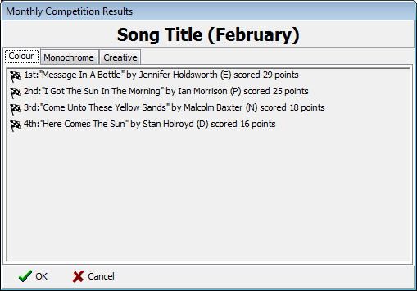

Again, this is split into tabs for each of the categories. Clicking on the “Save Competition Results” will enable you to save the results as a ‘CSV’ file (comma separated values), which can be imported into Microsoft Excel, or other suitable spread sheet. The difference between displaying the results in a window and saving them to a file is that the window will only show the number of places specified in the season configuration, while the file will contain all results.

Each entry has a ‘finish’ icon to the left – this displays a breakdown of which positions were awarded, starting from 1st down to, in this case, 4th (or more if configured).

## Photographer Of The Year

You can also click on the same buttons, but for Photographer of the Year results, to display (or save) these results. Both are similar to the above.

# Populating The Members List

## Manually

To enter each member, you can click on the ‘+’ icon to create an entry, and then type in their name. Pressing the TAB key will take you from the forename field to the surname field. If both are filled in, then pressing TAB again will create another new entry ready for another member.

## From a previous season file

If you have a season file, say from the previous year, that you wish to transfer the members across, just click on the Load Members List From Existing Season button and select the season file to reuse. Note that this will dispose of any members currently entered in favour of those in the existing file, resetting all photographs to having no author.

## From a CSV file

You may have an Excel spread sheet with all the members’ details listed. This can also be imported into the application. However, you will need to export just the Forename and Surname fields (as the only two fields, in that order) as a ‘CSV’ file (comma separated value). This method adds the members to any already entered, but will not duplicate any members already entered.

The application will reject a CSV file that has more, or less, than two fields per entry.

## Deleting Members

Down the right hand side of the list of members you will see a column of red ‘X’. Clicking on these will delete the appropriate member from the list, after confirming it with you first. However, not all members will have this option – only those that have not entered any photographs in the season can be deleted.

# Importing CSV Files

When importing a CSV file, you will need to specify which columns to import, and what they are to be imported as. For example, when importing a CSV file containing the membership names, the columns will need to be marked to allow the application to know which is the surname and which is the forename. This achieved simply by clicking on the column header and changing the designation using the drop down list at the top of the dialogue box:

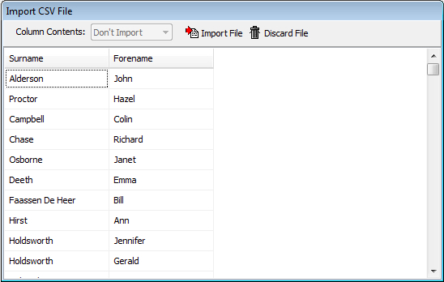

What each column is to be imported as is indicated at the column header. You cannot have more than one column with the same designation. You can specify not to import certain columns just by marking them as “Don’t Import”.

Importing photographs is very similar, but has more choices for the columns. For externally judged competitions, the Position column will be imported into the Judged Position column in the application.

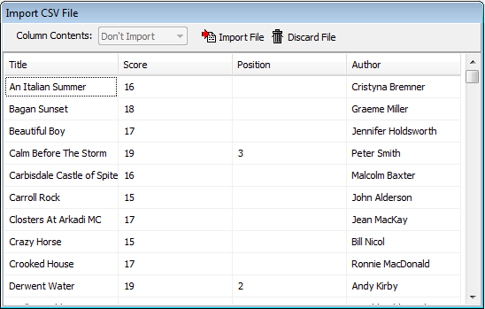

# Keyboard Shortcuts

To enable the use of the software without the use of a mouse, or quicker access to certain functions, there are some keyboard shortcuts. On most dialogue boxes, the Tab key moves you around the entry fields, Enter is the same as clicking ‘OK’ (or other confirmation button) and Escape is the same as clicking ‘Cancel’ (or other similar cancellation button).

The other shortcuts are defined thus:

|  |  |
| --- | --- |
| New Season | Ctrl+N |
| Open Season | Ctrl+O |
| Edit Season | Ctrl+E |
| Import Members | Ctrl+M |
| Display Photographers of the Year | Shift+Ctrl+A |
| Print Photographers of the Year | Shift+Ctrl+Q |
| Save Photographers of the Year | Shift+Ctrl+Z |
| Import Photographs | Shift+Ctrl+I |
| New Voting Slip | Shift+Ctrl+N |
| Delete Redundant Photographs | Shift+Ctrl+Delete |
| Recalculate Results | Shift+Ctrl+R |
| Display Competition Results | Shift+Ctrl+C |
| Print Competition Results | Shift+Ctrl+P |
| Save Competition Results | Shift+Ctrl+S |
| Go to the ESCC website | Shift+Ctrl+W |
| About the application | F1 |

# Other Functions

## Weblink

This, simply, opens up the computer’s default web browser and takes you to the ESCC home page.

## About

The final toolbar button opens a window to display the version information, and other information about the application. You can use this to ensure that you are using the latest version. There is also a link to the ESCC web page, which will open in the computer’s default web browser – an Internet connection is required for this.

## Disabled Buttons

As of writing, the application is still under development and, as such, not all buttons have code behind them:

* **Print Annual Results**

This will calculate and print the photographer of the year results.

* **Print Competition Results**

Similar to the Save Competition Results, this will output the monthly results to a printer (or PDF file, if suitable software is installed).